Project Design Phase-II

Data Flow Diagram & User Stories

Date | 20 February 2026
Team ID | LTVIP2026TMIDS24635
Project Name | FlightFinder – Navigating your air travel options
Maximum Marks | 4 Marks

Data Flow Diagrams:
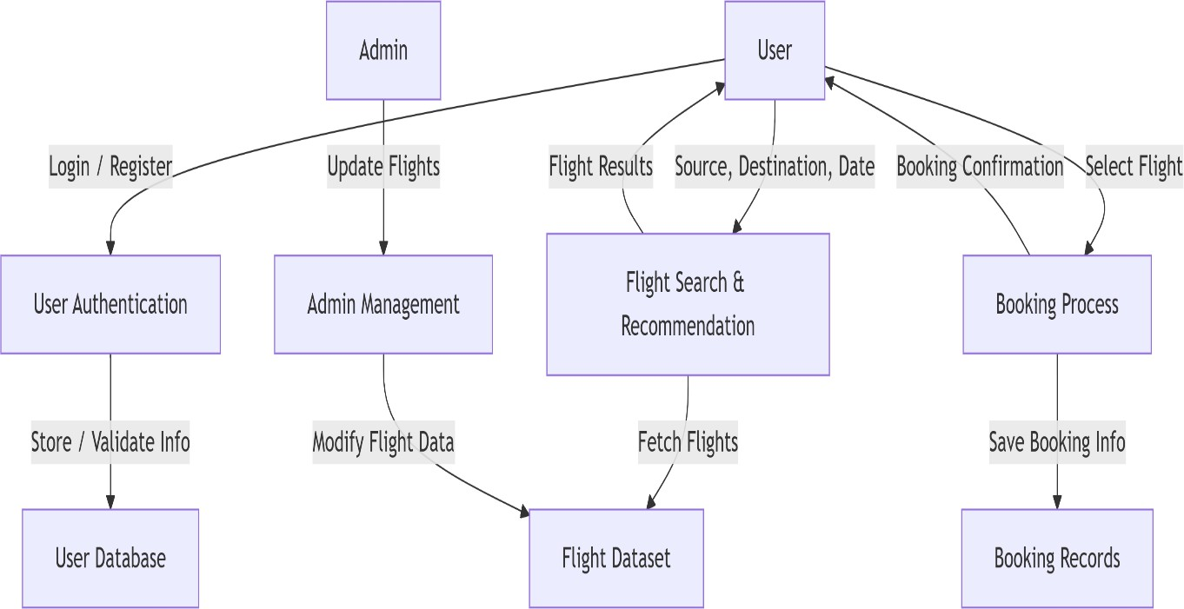
A Data Flow Diagram (DFD) is a traditional visual representation of the information flows within a system. A neat and clear DFD can depict the right amount of the system requirement graphically. It shows how data enters and leaves the system, what changes the information, and where data is stored.

User Stories

User Type | Functional  Requirement (Epic) | User Story Number | User Story / Task | Acceptance criteria | Priority | Release
Customer (User) | Registration | USN-1 | As a user, I can register for the application by entering my email, password, and confirming my password. | User account is created successfully and redirected to login page. | High | Sprint-1
Customer (User) | Login | USN-2 | As a user, I can log in using registered credentials. | User is authenticated and dashboard is displayed. | High | Sprint-1
Customer (User) | Flight Search | USN-3 | As a user, I can search flights by source, destination, and date. | Matching flight results are displayed correctly. | High | Sprint-1
Customer (User) | Flight Booking | USN-4 | As a user, I can book a flight by entering passenger details. | Booking is saved and confirmation is generated. | High | Sprint-2
Customer (User) | Booking Confirmation | USN-5 | As a user, I receive booking confirmation via email. | Confirmation email is delivered successfully. | Medium | Sprint-2
Flight Agency | Agency Registration | USN-6 | As a flight agency, I can register by submitting agency details. | Agency account request is submitted for admin approval. | High | Sprint-1
Admin | Agency Approval | USN-7 | As an admin, I can approve or reject flight agency registration requests. | Approved agencies gain access; rejected ones are notified. | High | Sprint-1
Flight Agency | Flight Management | USN-8 | As a flight agency, I can add flight details such as flight name, source, destination, time, and price. | Flight details are saved and sent for admin approval. | High | Sprint-2
Admin | Flight Approval | USN-9 | As an admin, I can approve or reject flight listings added by agencies. | Approved flights are visible to users for booking. | High | Sprint-2
Admin | Data Management | USN-10 | As an admin, I can view and manage all users, agencies, flights, and bookings. | Admin dashboard displays complete system data. | Medium | Sprint-2
Flight Agency | Flight Update | USN-11 | As a flight agency, I can update or delete my flight details. | Changes reflect only after admin approval. | Medium | Sprint-2
Customer (User) | View Flight Details | USN-12 | As a user, I can view full flight details before booking. | Complete flight information is displayed correctly. | Medium | Sprint-2

